Republic of the Philippines

**MUNICIPALITY OF BULAN**

SORSOGON

**BARANGAY J.P. LAUREL**

OFFICE OF THE PUNONG BARANGAY



**BARANGAY OFFICIALS**

**NORIE G. CAÑEZAL**

**Punong Barangay**

**BARANGAY KAGAWAD**

**MARY JANE G. ESQUILLO**

**JUNIE G. BREZUELA**

**LERMA O. GRANADIL**

**RENAN G. GOLLOSO**

**VENER P. BERANIA**

**FLORENCE M. SUS**

**JOSEPH H. ALMOGUERA**

**SK CHAIRMAN**

**RONNEL G. GUETA**

**EDNA H. BONAGUA**

Barangay Secretary

**AGNES R. JUAB**

Barangay Treasurer

**CERTIFICATE OF APPEARANCE**

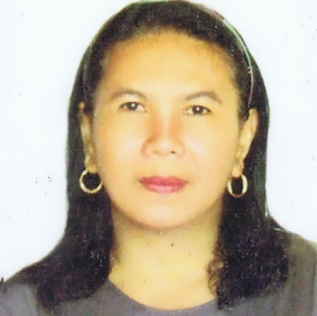

This is to certify that ______________________________, Immersion Outreach Program of Municipal Social Welfare and Development Office-Bulan, has been appeared in this office for the purpose of **Re-Organizing the Pag-asa Youth Association of the Philippines (PYAP) Members of Barangay J. P. Laurel, Bulan Sorsogon.**

**29**

**OCTOBER**

Given this ___th day of ______________, 2019.

|  |  |
| --- | --- |
| **EDNA H. BONAGUA**  Brgy. Secretary | **NORIE G. CAÑEZAL**  Punong Barangay |

|  |
| --- |
| **RONNEL G. GUETA**  SK Chairman |

Republic of the Philippines

**MUNICIPALITY OF BULAN**

SORSOGON

**BARANGAY J.P. LAUREL**

OFFICE OF THE PUNONG BARANGAY



**BARANGAY OFFICIALS**

**NORIE G. CAÑEZAL**

**Punong Barangay**

**BARANGAY KAGAWAD**

**MARY JANE G. ESQUILLO**

**JUNIE G. BREZUELA**

**LERMA O. GRANADIL**

**RENAN G. GOLLOSO**

**VENER P. BERANIA**

**FLORENCE M. SUS**

**JOSEPH H. ALMOGUERA**

**SK CHAIRMAN**

**RONNEL G. GUETA**

**EDNA H. BONAGUA**

Barangay Secretary

**AGNES R. JUAB**

Barangay Treasurer

**CERTIFICATE OF APPEARANCE**



This is to certify that ______________________________, Immersion Outreach Program of Municipal Social Welfare and Development Office-Bulan, has been appeared in this office for the purpose of **Planning and Budgeting of the Activities for the Pag-asa Youth Association of the Philippines (PYAP) Members of Barangay J. P. Laurel, Bulan Sorsogon.**

**NOVEMBER**

**12**

Given this ___th day of ________________, 2019.

|  |  |
| --- | --- |
| **EDNA H. BONAGUA**  Brgy. Secretary | **NORIE G. CAÑEZAL**  Punong Barangay |

|  |
| --- |
| **RONNEL G. GUETA**  SK Chairman |